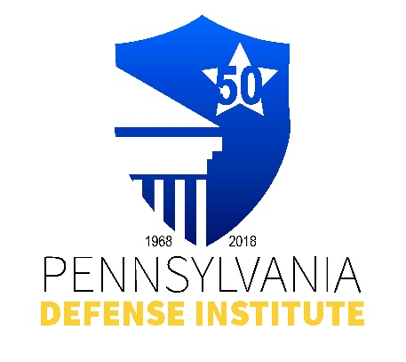

**PDI LUNCH TIME WEBINAR REGISTRATION FORM**

**Effective Engagement and Use of**

**An Expert Witness**

**Moderator: William “Bill” Ricci, Esquire, Ricci Tyrell Johnson & Grey**

**Panelists: Ronald J. Cohen, P.E., Civil Engineer, Michael E. Goldberg, CIH, CMP, Certified Industrial Hygiene and Safety Professional, and Andres J. Calderon, PhD., Biomechanical/Biomedical Engineer from Consulting Engineers & Scientists, Inc.**

**Wednesday, January 27, 2021**

**12:00 p.m. – 1:00 p.m.**

Webinar to be monitored by the PACLE Board for establishing PDI accreditation for Distance Learning CLE Credits. 1.0 Substantive CLE Credits t/b/d pending PACLE course approval.

Cost: Member - $25.00 __________ Non-Member - $35.00 __________

Registrant(s) Name:_____________________________________________________________

Firm Name and Address:­­­­­­­­­­­­­­­­­­­__________________________________________________________

E-mail Address:_________________________________________________________________

REGISTRATION AND PAYMENT METHODS:

_______ Complete Form and mail with check payable to “PDI” to: Pennsylvania Defense Institute, P.O. Box 6099, Harrisburg, PA 17112 and e-mail Registration to [cwasilefski@padefense.org](mailto:cwasilefski@padefense.org) or [lgamby@padefense.org](mailto:lgamby@padefense.org).

_______ Register online and mail a check payable to “PDI” at Pennsylvania Defense Institute, P.O. Box 6099, Harrisburg, PA 17112

_______ Go to PDI website: [www.padefense.org](http://www.padefense.org) and register using for provided on Events

Page and pay via PayPal.

**Upon receipt of Registration and Fee, Registrant will receive information for joining Webinar and required submission following Webinar via e-mail.**