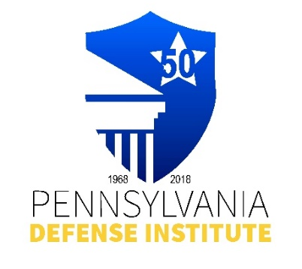
PDI LUNCH TIME WEBINAR REGISTRATION FORM

“School House Shock: A Look at
Pennsylvania’s Legislative Process”

Presented By: PDI LEGISLATIVE AFFAIRS COMMITTEE
and GREENLEE PARTNERS

Speakers: Jason M. Banonis, Esquire
Marshall Dennehey Warner Coleman & Goggin

Madison Stromswold
Greenlee Partners

Thursday, January 18, 2024
12:00 p.m. – 1:00 p.m.

CLE Credits: 1.0 Substantive CLE Credit

** FREE to Members of PDI**
Non-Members Cost - $35.00

Registrant(s) Name:_____________________________________________________________

Firm Name and Address:__________________________________________________________

E-mail Address:__________________________________________________________

REGISTRATION AND PAYMENT METHODS:

_______ Complete Form and mail with check payable to “PDI” to: Pennsylvania Defense Institute, P.O. Box 6099, Harrisburg, PA 17112 and e-mail Registration to cwasilefski@padefense.org or lgamby@padefense.org.

_______ Register online at: https://us06web.zoom.us/webinar/register/WN_rkjH6OVgR9u9BxAjpl1iqA and mail a check payable to “PDI” at Pennsylvania Defense Institute, P.O. Box 6099, Harrisburg, PA 17112

_______ Go to PDI website: www.padefense.org and register using for provided on Events
Page and pay via PayPal

Upon receipt of Registration and Fee, Registrant will receive information for joining Webinar and required submission following Webinar via e-mail.

