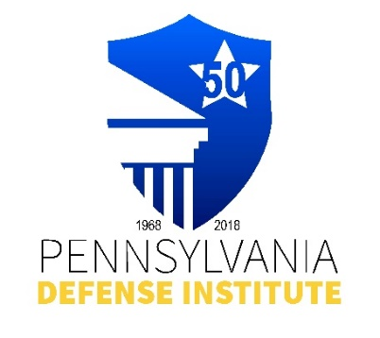
PDI LUNCH TIME WEBINAR REGISTRATION FORM

“Practical Tips for Premises Cases”

Presented By: FLEISHER FORENSICS

Speakers: David J. Littlewood, P.E. and Founder
Jared E. Barket, P.E.

Tuesday, September 17, 2024
12:00 p.m. – 1:00 p.m.
(Live via ZOOM)

CLE Credits: 1.0 Ethics CLE Credit

** FREE to Members of PDI**
Non-Members Cost - $35.00

Registrant(s) Name:_____________________________________________________________

Firm Name and Address:_________________________________________________________

E-mail Address:________________________________________________________________

REGISTRATION AND PAYMENT METHODS:

_______ Complete Form and mail with check payable to “PDI” to: Pennsylvania Defense Institute,
P.O..Box 6099, Harrisburg, PA 17112 and e-mail Registration to cwasilefski@padefense.org
or lgamby@padefense.org.

_______ Register online at: https://us06web.zoom.us/webinar/register/WN_iQ8HZ850SX290cKDq6aKdQ
and mail a check , if applicable, to PDI, P.O. Box 6099, Harrisburg, PA 17112

_______ Go to PDI website: www.padefense.org and register using for provided on Events Page and
pay via PayPal

Upon receipt of Registration and Fee, Registrant will receive information for joining Webinar and required submission following Webinar via e-mail.

