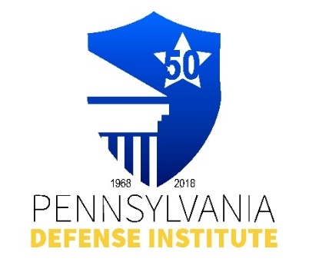
PDI LUNCH TIME WEBINAR REGISTRATION FORM

“The Role of Industrial Hygiene
& Safety in Litigation”

Wednesday, September 17, 2025
12:00 p.m. – 1:00 p.m.
ZOOM Live Presentation

Presented By: Michael E. Goldberg, CIH, CSP, Certified Industrial Hygenist
And Certified Safety Professional
CONSULTING ENGINEERS & SCIENTISTS, INC.

CLE Credits: 1.0 Substantive PACLE Credit

** FREE to Members of PDI **
Non-Members Cost - $35.00

Registrant(s) Name:_____________________________________________________________

Firm Name: ____________________________ E-mail:_____________________________

REGISTRATION AND PAYMENT METHODS:

_______ Complete Form and mail with check payable to “PDI” to: Pennsylvania Defense Institute,
P.O..Box 6099, Harrisburg, PA 17112 and e-mail Registration to cwasilefski@padefense.org
or lgamby@padefense.org.

_______ Register online: https://us06web.zoom.us/webinar/register/WN_0I2aFm9ARH-0TP84SmH78g
and mail check, if applicable, to PDI, P.O. Box 6099, Harrisburg, PA 17112

_______ Go to PDI website: www.padefense.org and register using for provided on Events Page and
pay via PayPal

ZOOM Confirmations will be provided the day of the event.

Upon receipt of Registration and Fee, Registrant will receive information for joining Webinar and required submission following Webinar via e-mail.

