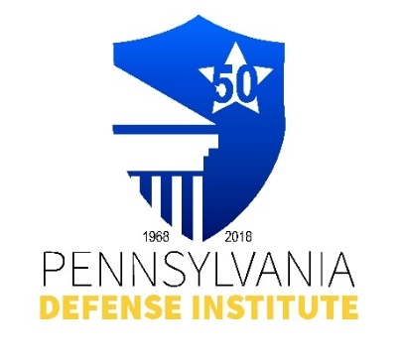
PDI LUNCH TIME WEBINAR REGISTRATION FORM

“Protecting Minors or Enforcing Contracts: Enforceability
of Parent-Signed Arbitration Agreements in Pennsylvania”

Thursday, March 12, 2026
12:00 p.m. – 1:00 p.m.
ZOOM Live Presentation

Presented By: Nicole Cramer, Esquire
SWEENEY & SHEEHAN

Focusing on Pennsylvania Supreme Court Decision in
Santiago v. Philly Trampoline Park LLC, Nos. 24 EAP 2023,
24 EAP 2023, 205 Pa. LEXIS 1501 (September 25, 2025)

CLE Credits: 1.0 Substantive PACLE Credit

** FREE to Members of PDI **
Non-Members Cost - $35.00

Registrant(s) Name:_____________________________________________________________

Firm Name: ____________________________ E-mail:_____________________________

REGISTRATION AND PAYMENT METHODS:

_______ Complete Form and mail with check payable to “PDI” to: Pennsylvania Defense Institute,
P.O..Box 6099, Harrisburg, PA 17112 and e-mail Registration to cwasilefski@padefense.org
or lgamby@padefense.org.

_______ Register online: https://us06web.zoom.us/webinar/register/WN_keHFh2ldTniOvO5v0I0KdQ
and mail check, if applicable, to PDI, P.O. Box 6099, Harrisburg, PA 17112

_______ Go to PDI website: www.padefense.org and register using for provided on Events Page and
pay via PayPal

ZOOM Confirmations will be provided the day of the event.

Upon receipt of Registration and Fee, Registrant will receive information for joining Webinar and required submission following Webinar via e-mail.

