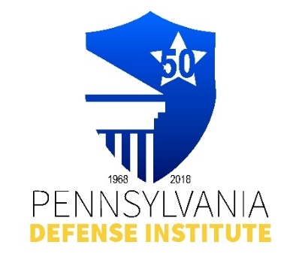
PENNSYLVANIA ASSOC. FOR HEALTH CARE RISK MANAGEMENT
(PACHRM), and
PENNSYLVANIA DEFENSE INSTITUTE
PRESENT

“Navigating the Digital Shift: Balancing
the Benefits and Legal Risks of Patient Portals”

Wednesday, February 11, 2026
12:00 p.m. – 1:30 p.m.
ZOOM Live Presentation

Presented By: Robert J. Aldrich, Esquire
MARSHALL DENNEHEY WARNER COLEMAN & GOGGIN
Melissa A. Dziak, Esquire
MARSHALL DENNEHEY WARNER COLEMAN & GOGGIN

CLE Credits: 1.5 Substantive PACLE Credit

** FREE to Members of PDI and PACHRM**
Non-Members Cost - $50.00

Registrant(s) Name:_____________________________________________________________

Firm Name: ____________________________ E-mail:_____________________________

REGISTRATION AND PAYMENT METHODS:

_______ Complete Form and mail with check payable to “PDI” to: Pennsylvania Defense Institute,
P.O..Box 6099, Harrisburg, PA 17112 and e-mail Registration to cwasilefski@padefense.org
or lgamby@padefense.org.

_______ Go to PDI website: www.padefense.org and register using for provided on Events Page and
pay via PayPal

ZOOM Confirmations will be provided after registration.

Upon receipt of Registration and Fee, Registrant will receive information for joining Webinar and required submission following Webinar via e-mail.

