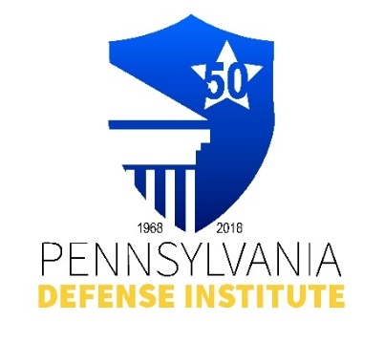
PDI and PENNSYLVANIA ASSOCIATION FOR HEALTH CARE
RISK MANAGEMENT (PACHRM)
INVITES YOU

2026 PACHRM ANNUAL MEETING

The Nittany Lion Inn
State College, PA

April 9-10, 2026

Thursday, April 9, 2026 9:00 a.m. – 4:00 p.m.
Friday, April 10, 2026 9:00 a.m. – 12:00 p.m.
Link to Agenda(s): https://padefense.org/event/pennsylvania-association-of-health-care-risk-management-phcrm-invites-pdi-members-to-phcrm-annual-conference-day-1/

CLE Credits: 8.0 Substantive PACLE Credits
1.0 Ethics PACLE Credit

Registration Cost $175.00 – Event/Courses Only – Room Registrations separate cost

Registrant(s) Name(s) ____________________________________________________________

Firm Name: ____________________________ E-mail: _____________________________

REGISTRATION AND PAYMENT METHODS:

_______ Complete Form and mail with check payable to “PDI” to: Pennsylvania Defense Institute,
P.O..Box 6099, Harrisburg, PA 17112 and e-mail Registration to cwasilefski@padefense.org
or lgamby@padefense.org.

_______ Go to PDI website: www.padefense.org and register using for provided on Events Page and
pay via PayPal

Upon receipt of Registration and Fee, Registrant will receive information for joining Webinar and required submission following Webinar via e-mail.

