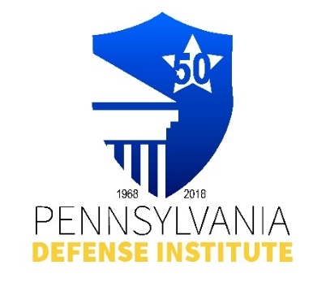
PENNSYLVANIA DEFENSE INSTITUTE (PDI)
AND
PENNSYLVANIA ASSOCIATION FOR JUSTICE (PAJ)
INVITE YOU

2026 Trial Academy

Penn State Dickinson School of Law
University Park, PA

May 27-29, 2026

Wednesday, May 27, 2026 4:00 – 5:00 p.m. Check-in
5:30 – 7:00 p.m. Reception
Thursday, May 28, 2026 7:00 – 8:00 a.m. Breakfast
8:30 a.m. – 5:15 p.m. Academy Sessions
Friday, May 29, 2026 7:00 – 8:00 a.m. Breakfast
7:30 a.m. – 1:00 p.m. Academy Session
Link to Full Agenda(s): https://padefense.org/event/pdi-paj-trial-academy-day-1-of-instruction/
https://padefense.org/event/pdi-paj-trial-academy-day-2/

CLE Credits: 11.0 Substantive PACLE Credits

Registration Cost $650.00 – Event/Courses Only – Room Registrations separate cost:
https://reservations.travelclick.com/9877652?groupID=5172441

Registrant(s) Name(s) ____________________________________________________________

Firm Name: ____________________________ E-mail: _____________________________

REGISTRATION AND PAYMENT METHODS:

_______ Complete Form and mail with check payable to “PDI” to: Pennsylvania Defense Institute,
P.O..Box 6099, Harrisburg, PA 17112 and e-mail Registration to cwasilefski@padefense.org
or lgamby@padefense.org.

_______ Go to PDI website: www.padefense.org and register using for provided on Events Page and
pay via PayPal

Upon receipt of Registration and Fee, Registrant will receive information for joining Webinar and required submission following Webinar via e-mail.

